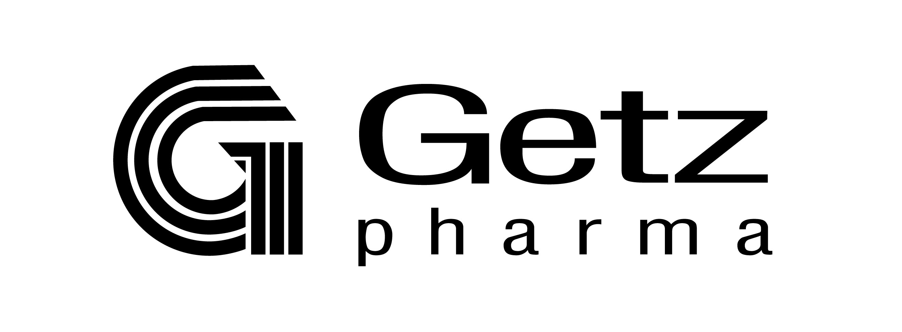

Products Section Form

Product Details
√ New Existing
Generic Name | Solifenacin Succinate
Therapeutic Segment | Urogynecologic
Product Name / Brand(s) | Solifen
Form(s) | Tablet
Strength(s) | 5MG
Country(s) | Laos
Brand Status | R
Indication/(s) | Indicated for:  - Treatment of overactive bladder with symptoms of urge urinary incontinence, urgency and urinary frequency or frequent micturition.
Show on Website (Y/N) | Y
Comments / Specific Instructions:

Prepared By | Reviewed By | Approved By | Approved By | Received By
Omer Mujeeb  Trainee Business Development | M. Ghazanfar Nizami  Business Manager | Imtiaz Razzaq  Director International Business | Mahmood A. Aziz  Director BD, Sourcing & Special Projects | Farah Batool  Manager Corporate Communications
Date: | Date: | Date: | Date: | Date:

